**Delivery Information:** When it comes to the enter image text, no matter if I enter it right or wrong, the system does not take it. So, technically, I cannot neither register nor checkout and buy what’s in my cart! Please try to sign up yourself and check what’s happening! The whole point behind our website is to generate sales, and if it’s not working than it’s a problem!

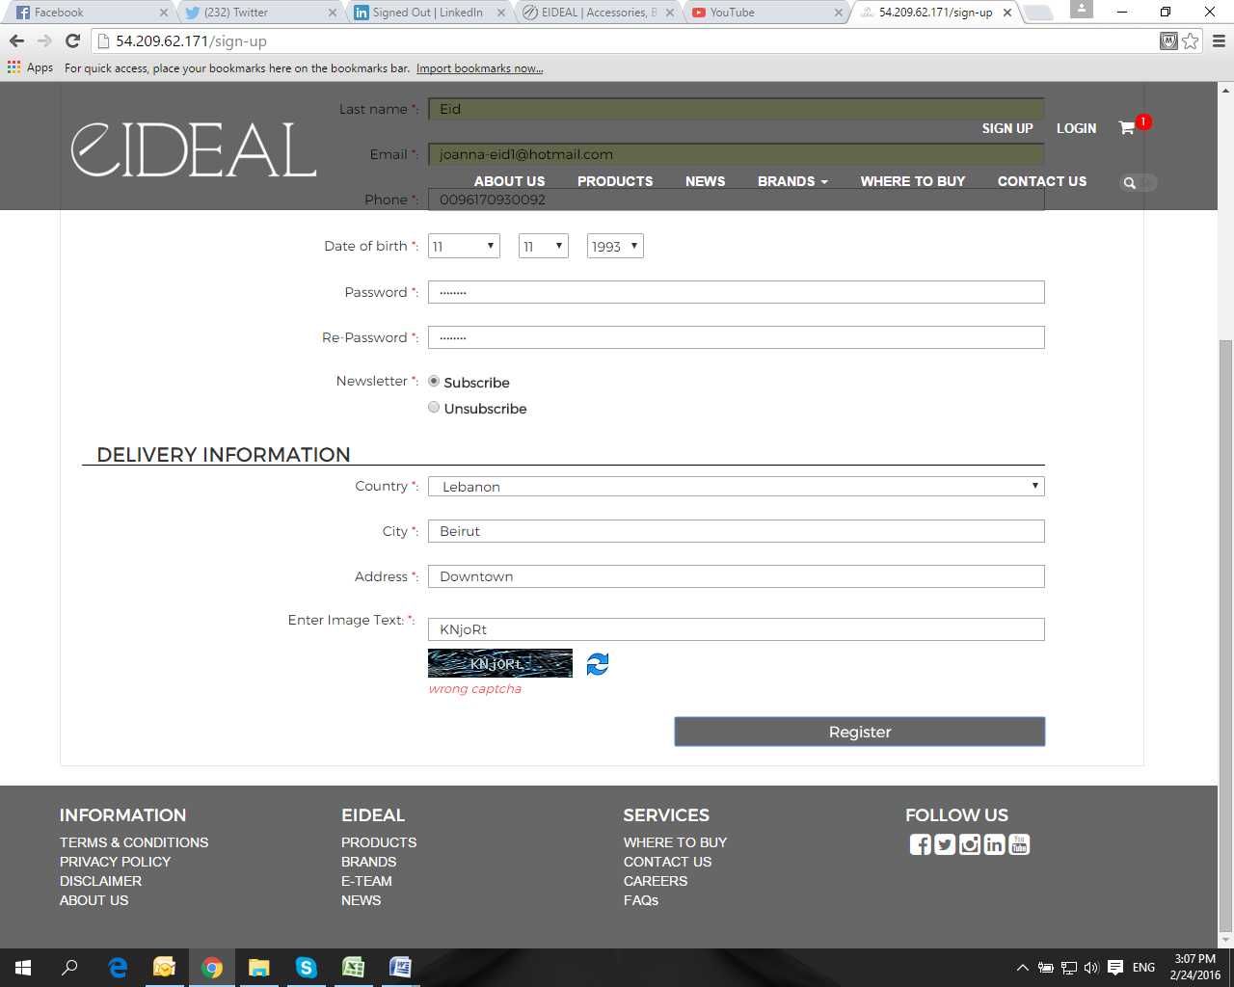

It would be great if you could test out the fields such as the above in addition to the ones in career just to make sure that they’re all working properly to avoid any further delays. I tried to test the careers one but I’m not sure whether it worked or not!

**Amazon Media:** I have been adding the media date manually ever since the beginning when it comes to all brands but for some reason it did not work for the Amazon and the date would automatically be replace to 0000-00-00 00:00:00

**Promotional Code:** Attached in the email is the contract. Please refer to page #4 and check the Frontend Application, it says in point #5 “Development of all pages currently existing in the website” and we had this option on our old one. On a separate note, Haysam has mentioned that he has previously discussed this on skype with Michel when the website was in process.